York University
28.06.2004in current news

‘Guardian of paradise’ dies – Alexander F. Skutch
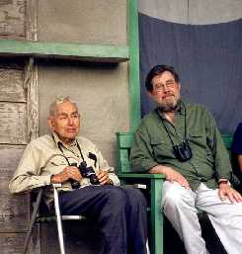
Internationally known naturalist, botanist, ornithologist and philosopher Alexander Skutch died peacefully at his home in Costa Rica on May 12, just eight days short of his 100th birthday.

Known affectionately as "don Alejandro", Dr. Skutch was a friend and mentor to many York University students doing field research or volunteer work in the Las Nubes region of Costa Rica.

Left: Alexander Skutch, left, with Professor Howard Daugherty, director of the research program at York’s Las Nubes Rainforest in Costa Rica, at Los Cusingos, in a photo taken a few years ago

Susan Hall (MES '01) described her experience with don Alejandro:

"As everyone knows, Dr. Skutch’s contributions to science, ornithology and tropical ecology are unparalleled. He was truly a pioneer in the exploration of Central American flora and fauna. Behind the naturalist and ornithologist was a wonderful person, who I was fortunate enough to call a neighbour and a friend.

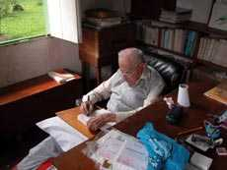
Right: Alexander Skutch in his office

"Don Alejandro’s gentle nature, warm smile and listening ear were always welcoming when I walked down the hill to his home for an early-morning or late-afternoon visit. We would frequently sit on the front porch – sometimes in silence admiring the view, sometimes talking about the species I had seen while walking through Los Cusingos or the progress of my research in the area. Whenever I received letters from home, he was always interested to hear about my family and any news from Canada. We spent a great deal of time sharing stories about adventures, especially his during the early years in Costa Rica. He was an inspiration to me both as a scientist and a human being. From him, I learned a great deal about the value of compassion, holding true to your beliefs, and being an individual. I feel exceptionally fortunate to have had the opportunity to have him as a friend."

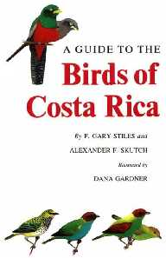
Dr. Skutch was best known for his work on the life histories of Central American birds. He was the author of over 30 books about nature, including A Guide to the Birds of Costa Rica, The Mind of Birds and A Naturalist on a Tropical Farm (left). He also published over 300 journal articles and several books on philosophy, such as Life Ascending.

Shortly after receiving his PhD in botany from Johns Hopkins University in 1928, Dr. Skutch began working in Panama. He soon became enamoured with the beauty and antics of the rufous-tailed hummingbird near his windowsill; thus began his lifelong journey into the splendour of tropical birds. He remained an ardent botanist throughout his life, sending hundreds of specimens to museums around the world. He discovered several new species, including nine new orchids in Costa Rica and two in Guatemala.

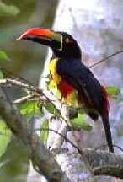
After a decade of travels and observations throughout Central America, Dr. Skutch bought a parcel of forest in 1941 that was to become his home for over 60 years. This land he named "Los Cusingos" in honor of the fiery-billed aracari (right) common to the area.

Since 1993 this has been the Los Cusingos Neotropical Bird Sanctuary of the Tropical Science Center, York’s partner organization in Costa Rica. Los Cusingos and Las Nubes comprise the lower and higher ends, respectively, of the Alexander Skutch Biological Corridor. These areas are biological treasures that form a part of the larger Mesoamerican Biological Corridor.

The Costa Rican newspaper La Nación eulogized Alexander Skutch as "the guardian of paradise." A gentle, peaceful, humble man – York University is indeed fortunate to have had him as a friend.

Faculty of Environmental Studies Professor Howard Daugherty, director of the research program at York’s Las Nubes Rainforest in Costa Rica, sent this article to YFile.
For more University news, photos and videos, visit the YFile homepage.

